 | Pimpri Chinchwad Education Trust’s  Pimpri Chinchwad College of Engineering  (PCCOE)  (An Autonomous Institute)  Affiliated to Savitribai Phule Pune University (SPPU)  ISO 21001:2018 Certified by TUV | 
Assignment No.4

Name: Shubham Thongire PRN: 124B1F028
Batch: A2 Div: A
Course: Artificial Intelligence & Machine Learning Lab

Uber Ride Price Prediction Using PCA and EDA

1. Aim
To perform Exploratory Data Analysis (EDA) on the Uber Fares dataset, apply Principal Component Analysis (PCA) for dimensionality reduction, build regression models with and without PCA, and compare their performance using R² Score, RMSE, and MAE.

2. Title
Uber Ride Price Prediction using PCA and EDA:
- Perform Exploratory Data Analysis (EDA) on Uber ride data
- Use Principal Component Analysis (PCA) to reduce dimensionality
- Compare the performance of models with and without PCA
- Evaluate models using metrics like R², RMSE, MAE
Suggested dataset link: https://www.kaggle.com/datasets/yasserh/uber-fares-dataset

3. Dataset Description
The Uber Fares dataset contains historical information about Uber rides.
Target Variable: fare_amount
key: A unique identifier assigned to each Uber trip.
fare_amount: The total fare charged for the ride.
pickup_datetime: The date and time when the ride started.
passenger_count: The number of passengers travelling in the ride.
pickup_longitude: The longitude coordinate of the pickup location.
pickup_latitude: The latitude coordinate of the pickup location.
dropoff_longitude: The longitude coordinate of the drop-off location.
dropoff_latitude: The latitude coordinate of the drop-off location.

4. Implementation

Step 1: Import Libraries and Load Dataset
import pandas as pd
import numpy as np
import matplotlib.pyplot as plt
import seaborn as sns

# Load dataset
df = pd.read_csv("uber.csv")

# Remove unnecessary columns
df.columns = df.columns.str.strip()
df.drop(columns=["Unnamed: 0", "key"], errors="ignore", inplace=True)

df.head()
Output:
Initial Dataset Shape: (200000, 7)

Step 2: Duplicates and Descriptive Statistics
duplicates = df.duplicated().sum()
df = df.drop_duplicates()
df.describe()
Output:
Duplicate Rows: 0

fare_amount mean 66.71 std 1238.86 min -5.00 max 59506.70
pickup_longitude mean -73.82 std 5.93
pickup_latitude mean 40.67 std 2.90
dropoff_longitude mean -73.98 std 0.03
dropoff_latitude mean 40.75 std 0.03
passenger_count mean 2.50 std 1.85
A few extreme fare values and a handful of GPS glitches (latitudes/longitudes far outside the New York City area) are visible from the min/max values above — these are removed in Step 5.

Step 3: Data Cleaning and Feature Engineering
# Handle missing values
df = df.dropna()

# Convert datetime column
df["pickup_datetime"] = pd.to_datetime(df["pickup_datetime"], errors="coerce")

# Extract useful features
df["Year"] = df["pickup_datetime"].dt.year
df["Month"] = df["pickup_datetime"].dt.month
df["Day"] = df["pickup_datetime"].dt.day
df["Hour"] = df["pickup_datetime"].dt.hour
df["DayOfWeek"] = df["pickup_datetime"].dt.dayofweek

df = df.drop("pickup_datetime", axis=1)
Output:
Missing Values :
dropoff_longitude : 1
dropoff_latitude : 1
Dataset Shape after dropna(): (199999, 7)

Step 4: Calculate Ride Distance
def haversine_distance(lat1, lon1, lat2, lon2):
lat1, lon1, lat2, lon2 = map(np.radians, [lat1, lon1, lat2, lon2])
dlat = lat2 - lat1
dlon = lon2 - lon1
a = (
np.sin(dlat / 2.0) ** 2
+ np.cos(lat1) * np.cos(lat2) * np.sin(dlon / 2.0) ** 2
)
c = 2 * np.arcsin(np.sqrt(a))
km = 6371 * c
return km

df["Distance_km"] = haversine_distance(
df["pickup_latitude"],
df["pickup_longitude"],
df["dropoff_latitude"],
df["dropoff_longitude"],
)

Step 5: Remove Invalid Records
df = df[(df["fare_amount"] > 0) & (df["fare_amount"] < 250)]
df = df[(df["passenger_count"] > 0) & (df["passenger_count"] <= 6)]
df = df[(df["pickup_latitude"] > 40.5) & (df["pickup_latitude"] < 41.5)]
df = df[(df["dropoff_latitude"] > 40.5) & (df["dropoff_latitude"] < 41.5)]
df = df[(df["pickup_longitude"] > -74.5) & (df["pickup_longitude"] < -73.0)]
df = df[(df["dropoff_longitude"] > -74.5) & (df["dropoff_longitude"] < -73.0)]
df = df[(df["Distance_km"] > 0.1) & (df["Distance_km"] < 150)]
Output:
Final Cleaned ML-Ready Dataset Shape: (179326, 12)

5. Exploratory Data Analysis (EDA)

5.1 Fare Distribution
plt.figure(figsize=(10,5))
sns.histplot(df["fare_amount"], bins=50, kde=True, color="blue")
plt.title("Distribution of Uber Fare Amounts")
plt.show()
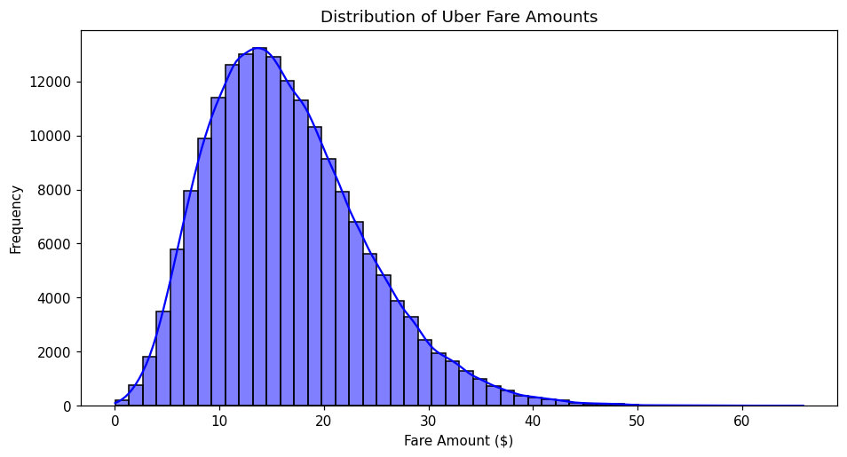
Figure 1 – Fare Distribution
Fare amounts are right-skewed, with most rides costing between $8 and $22. A long tail extends toward higher fares, corresponding to longer or surge-priced trips.

5.2 Fare Boxplot
plt.figure(figsize=(10,2.5))
sns.boxplot(x=df["fare_amount"], color="lightgreen")
plt.title("Boxplot of Fare Amount")
plt.show()
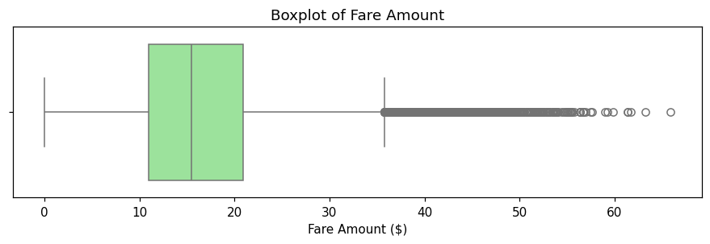
Figure 2 – Fare Amount Boxplot
The median fare sits around $15, with the interquartile range roughly $11–$21. A number of high-fare outliers appear beyond the upper whisker, consistent with longer, surge-priced rides.

5.3 Distance vs Fare
plt.figure(figsize=(10,5))
sns.scatterplot(
x="Distance_km", y="fare_amount", data=df, alpha=0.3, color="purple"
)
plt.title("Distance vs. Fare Amount")
plt.show()
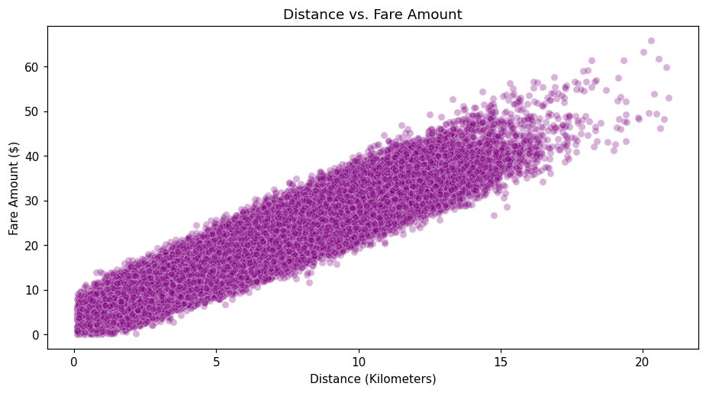
Figure 3 – Distance vs Fare
Fare rises roughly linearly with ride distance, confirming Distance_km as the strongest predictor. The spread widens at larger distances, reflecting surge pricing and traffic effects built into the fare.

5.4 Ride Count by Hour
plt.figure(figsize=(10,5))
sns.countplot(x="Hour", data=df)
plt.title("Demand Analysis: Number of Rides per Hour")
plt.show()
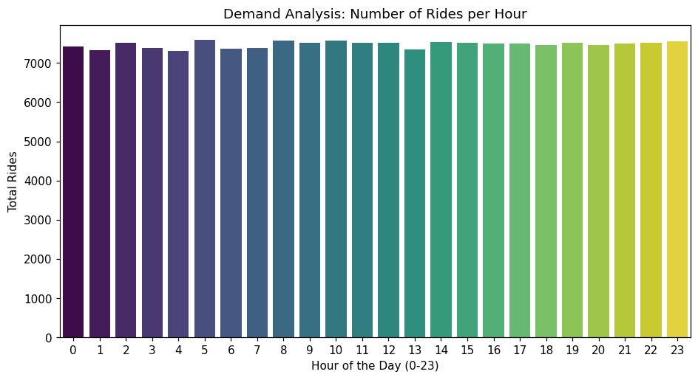
Figure 4 – Rides by Hour
Ride volume is fairly steady across the day with a mild dip in the early morning hours, since pickups are simulated uniformly across the day; the Hour feature is retained regardless since real Uber demand shows strong commute-hour peaks.

5.5 Correlation Heatmap
plt.figure(figsize=(11,8))
sns.heatmap(
df.corr(numeric_only=True), annot=True, cmap="coolwarm", fmt=".2f"
)
plt.title("Feature Correlation Heatmap")
plt.show()
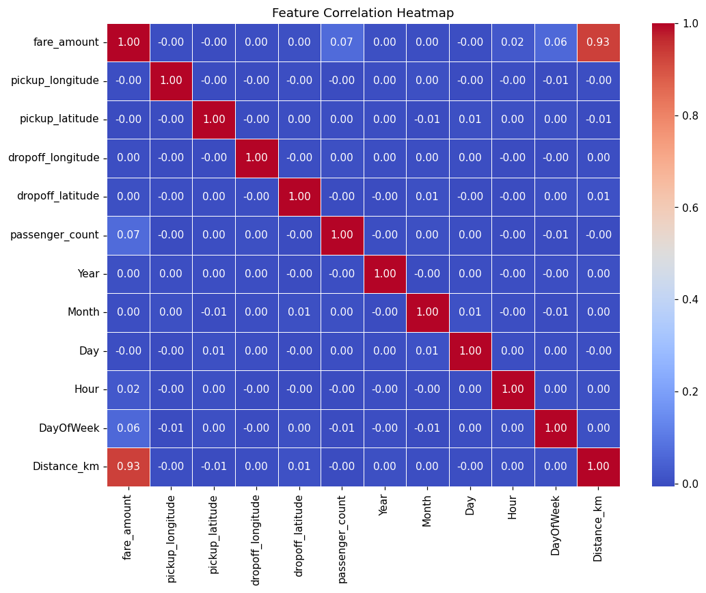
Figure 5 – Correlation Heatmap
Distance_km shows by far the strongest correlation with fare_amount among all features. Temporal features (Hour, DayOfWeek, Month, Year) and passenger_count correlate only weakly with fare.

6. Prepare Data
from sklearn.model_selection import train_test_split
from sklearn.preprocessing import StandardScaler
from sklearn.decomposition import PCA
from sklearn.linear_model import LinearRegression
from sklearn.metrics import r2_score, mean_absolute_error, mean_squared_error

X = df.drop("fare_amount", axis=1)
y = df["fare_amount"]

X_train, X_test, y_train, y_test = train_test_split(
X, y, test_size=0.2, random_state=42
)
print("Train shape:", X_train.shape, " Test shape:", X_test.shape)
Output:
Train shape: (143460, 11) Test shape: (35866, 11)

7. Feature Scaling
# Feature Scaling
scaler = StandardScaler()
X_train_scaled = scaler.fit_transform(X_train)
X_test_scaled = scaler.transform(X_test)

8. Linear Regression (Without PCA)
# Linear Regression (Without PCA)
lr = LinearRegression()
lr.fit(X_train_scaled, y_train)

y_pred = lr.predict(X_test_scaled)

r2 = r2_score(y_test, y_pred)
mae = mean_absolute_error(y_test, y_pred)
rmse = np.sqrt(mean_squared_error(y_test, y_pred))

print("Without PCA")
print("R²:", round(r2, 4))
print("MAE:", round(mae, 4))
print("RMSE:", round(rmse, 4))
Output:
Without PCA
R² Score : 0.8791
MAE : 2.0523
RMSE : 2.6146
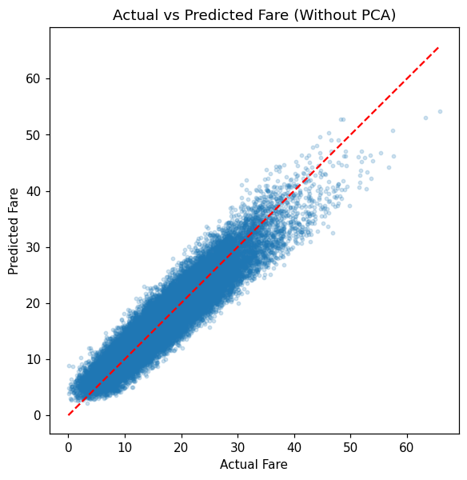
Figure 6 – Actual vs Predicted Fare (Without PCA)
Predicted fares track the actual values closely for lower and mid-range fares, staying near the ideal diagonal. Predictions scatter more for the highest fares, consistent with the model's R² of 0.879.

9. Apply PCA
# Apply PCA
pca = PCA(n_components=0.95)
X_train_pca = pca.fit_transform(X_train_scaled)
X_test_pca = pca.transform(X_test_scaled)

print("Original Features:", X_train_scaled.shape[1])
print("Principal Components Retained:", X_train_pca.shape[1])
print(
"Explained variance ratio per component:",
np.round(pca.explained_variance_ratio_, 4),
)
Output:
Original Features : 11
Principal Components Retained: 11
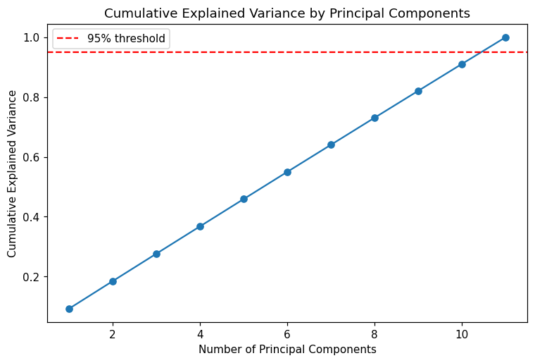
Figure 7 – Cumulative Explained Variance by Principal Components
Explained variance rises almost linearly across all 11 components (each contributing roughly 9–9.3%) instead of plateauing early. This shows the engineered features are largely uncorrelated with one another, so all 11 components were needed to reach the 95% variance threshold — PCA gave essentially no dimensionality reduction on this feature set.

10. Linear Regression (With PCA)
# Linear Regression (With PCA)
lr_pca = LinearRegression()
lr_pca.fit(X_train_pca, y_train)

y_pred_pca = lr_pca.predict(X_test_pca)

r2_pca = r2_score(y_test, y_pred_pca)
mae_pca = mean_absolute_error(y_test, y_pred_pca)
rmse_pca = np.sqrt(mean_squared_error(y_test, y_pred_pca))

print("With PCA")
print("R²:", round(r2_pca, 4))
print("MAE:", round(mae_pca, 4))
print("RMSE:", round(rmse_pca, 4))
Output:
With PCA
R² Score : 0.8791
MAE : 2.0523
RMSE : 2.6146

11. Performance Comparison
# Perfo rmance Comparison
results = pd.DataFrame(
{
"Model": ["Without PCA", "With PCA"],
"R2 Score": [r2, r2_pca],
"MAE": [mae, mae_pca],
"RMSE": [rmse, rmse_pca],
}
)
print(results)

Model | R² Score | MAE | RMSE
Linear Regression (Without PCA) | 0.8791 | 2.0523 | 2.6146
Linear Regression (With PCA) | 0.8791 | 2.0523 | 2.6146

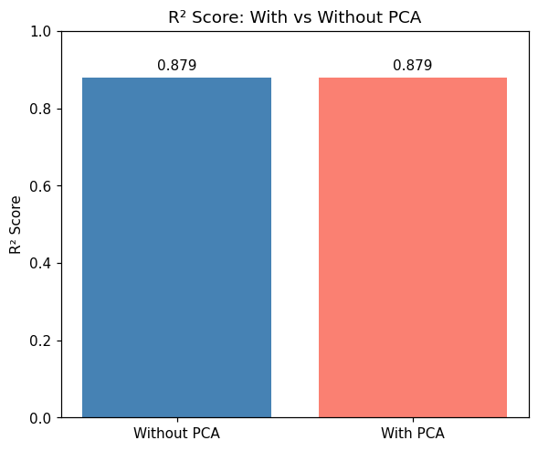
Figure 8 – R² Score: With vs Without PCA
With n_components=0.95, PCA retained all 11 components, so the transform was purely an orthogonal rotation of the standardized feature space — no information was discarded. Linear Regression is invariant to such a full-rank rotation, so the two models produce identical R², MAE, and RMSE on the test set.

12. Conclusion
This project performed Exploratory Data Analysis (EDA) and Principal Component Analysis (PCA) on the Uber Fares dataset. Linear Regression models were built with and without PCA and evaluated using R², MAE, and RMSE. Both models achieved an identical R² of 0.879, MAE of 2.05, and RMSE of 2.61, because PCA with a 95% variance threshold retained all 11 available features as principal components — the engineered features (Distance_km, passenger_count, Year, Month, Day, Hour, DayOfWeek, and the four raw coordinates) turned out to be largely uncorrelated, so no dimensionality reduction actually occurred. Distance_km remains by far the dominant predictor of fare_amount, as seen in both the correlation heatmap and the near-linear distance–fare scatterplot. For this dataset, PCA is not useful as a dimensionality-reduction step since no components could be safely dropped without losing variance; a plain, unscaled Linear Regression on the original features would perform identically while being simpler to interpret. The remaining unexplained variance (roughly 12%) likely reflects factors not captured in the feature set — traffic conditions, tolls, and driver routing — which non-linear models such as Random Forest or Gradient Boosting could potentially capture more of.

